**Crud Operation in MongoDB Database using MongoDB Connector**

1. Click on file select integration project.

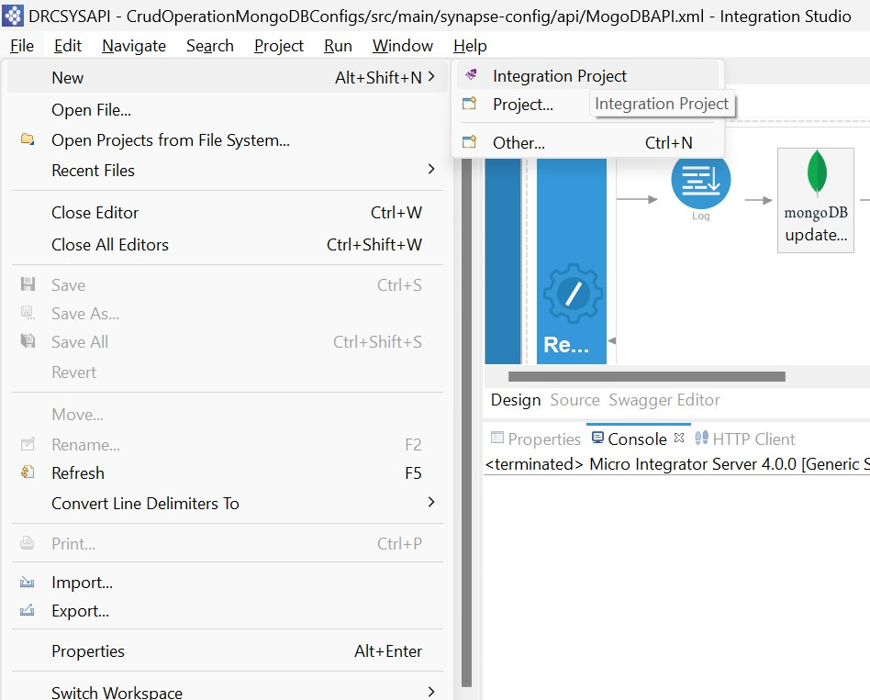

1. Select ESB config, Composite Exporter and Connector Exporter and enter name of project and click on finish.

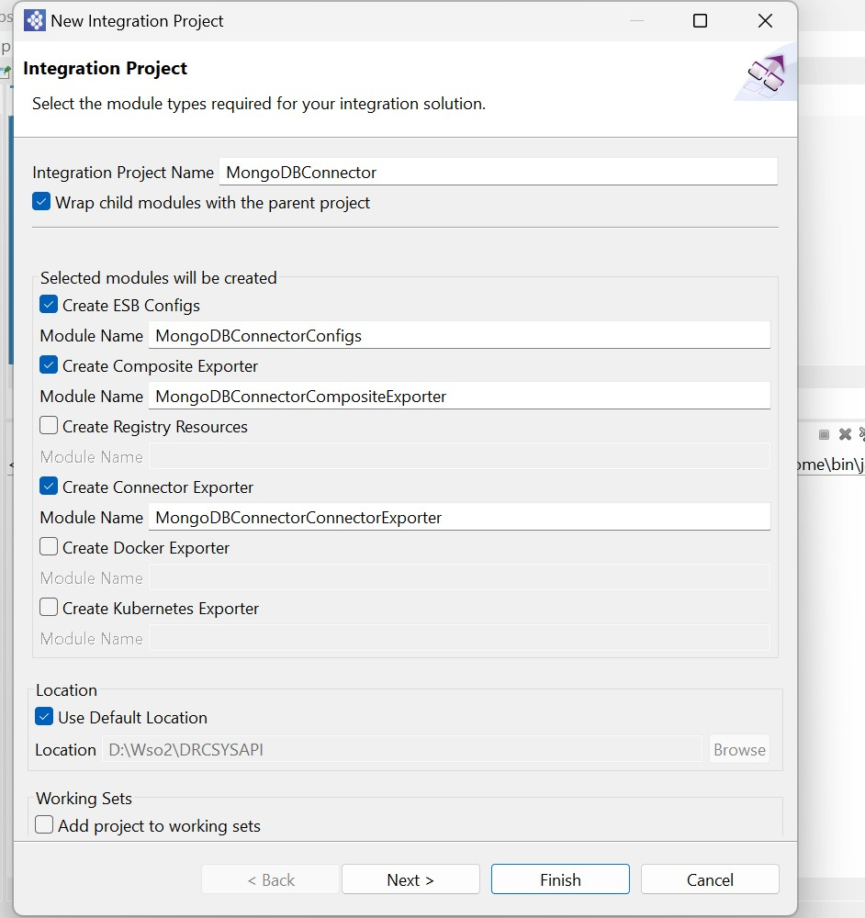

1. Click on library add Mongo DB Java jar file in lib.

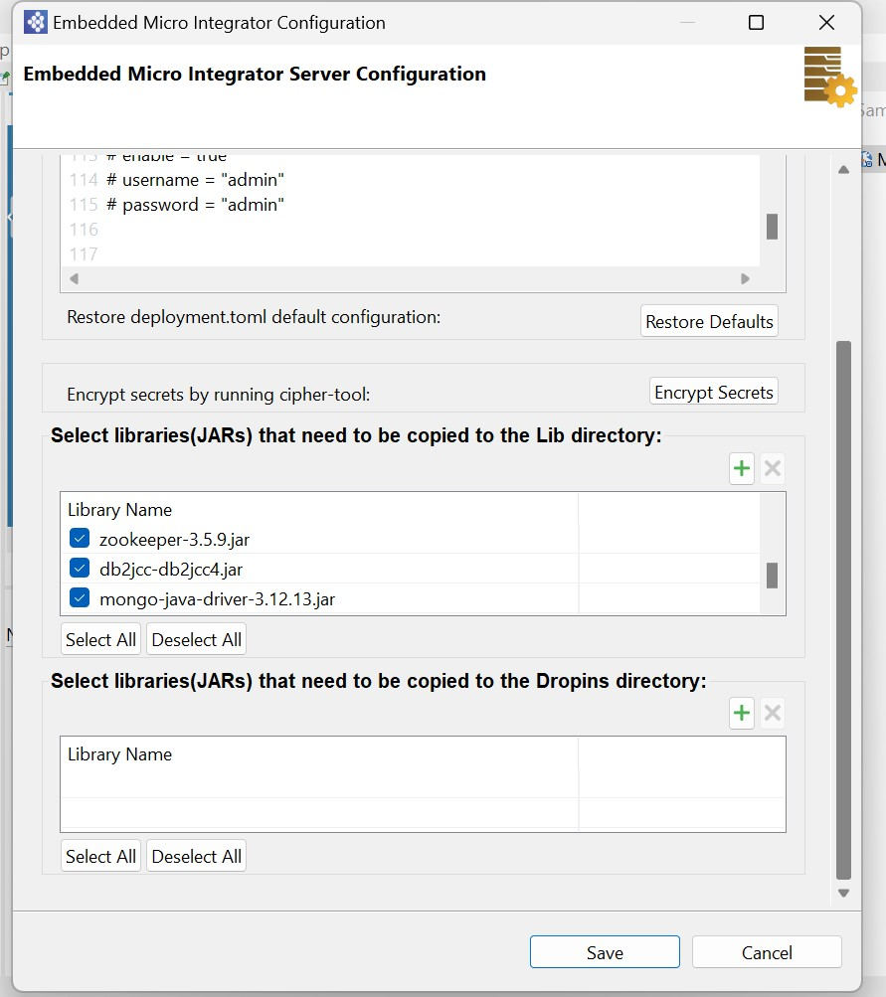

1. Click on API artifact in ESB Config and click new, select REST API

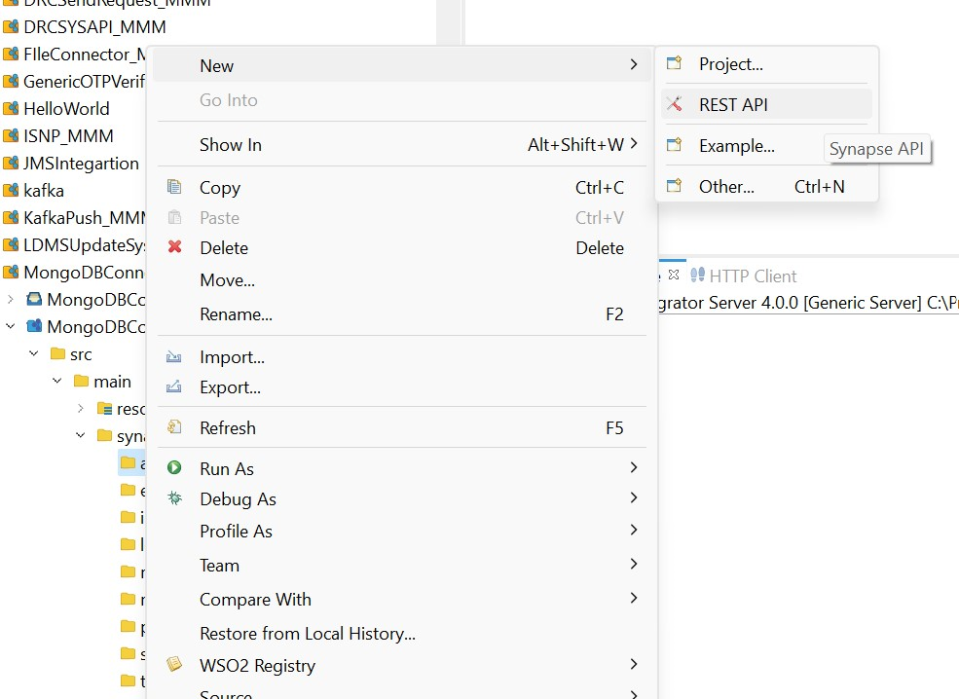

1. Select Create new API artifact and click on next

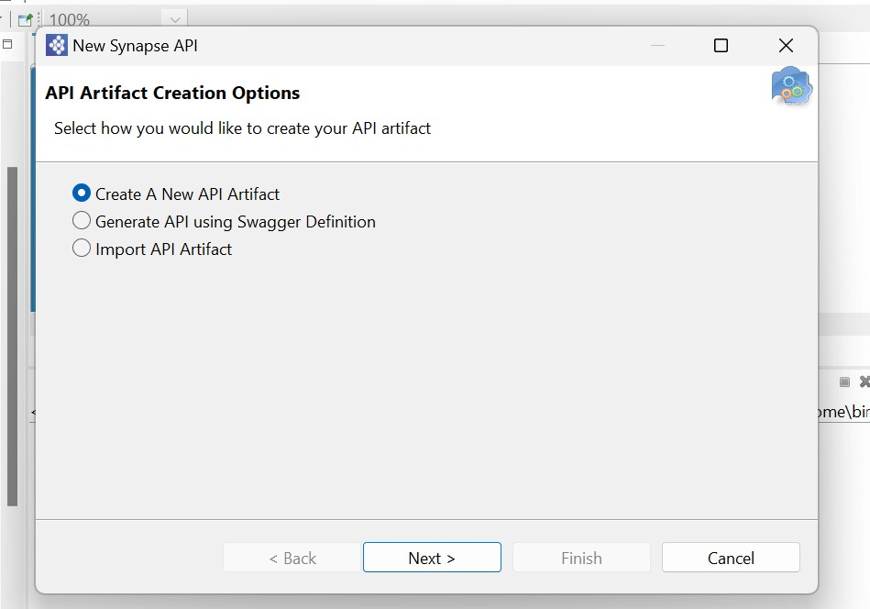

1. Enter Name and context of API and click on next.

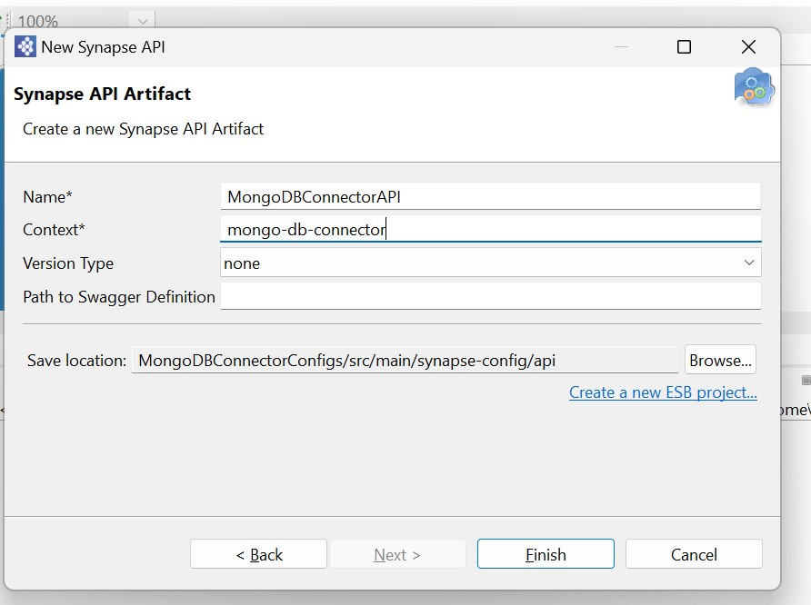

1. Double-click the Resource icon on the left side of the canvas.
2. On the Properties tab, provide the following as Basic properties:

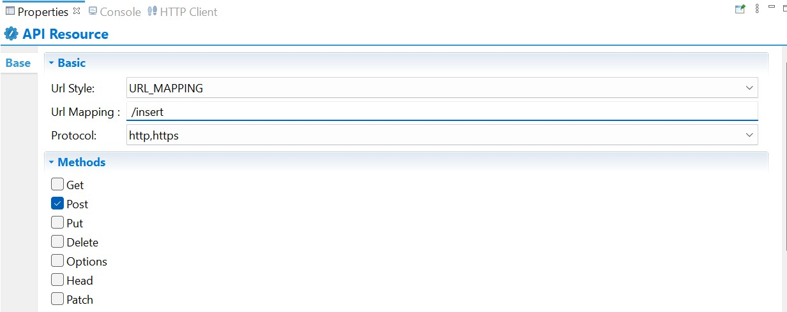

1. Right Click on ESB Config and click on add/remove Connector

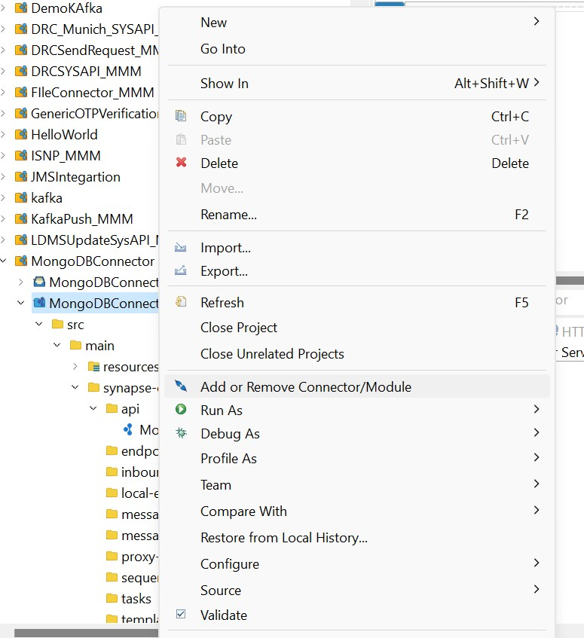

1. Click on Add Connector/Module

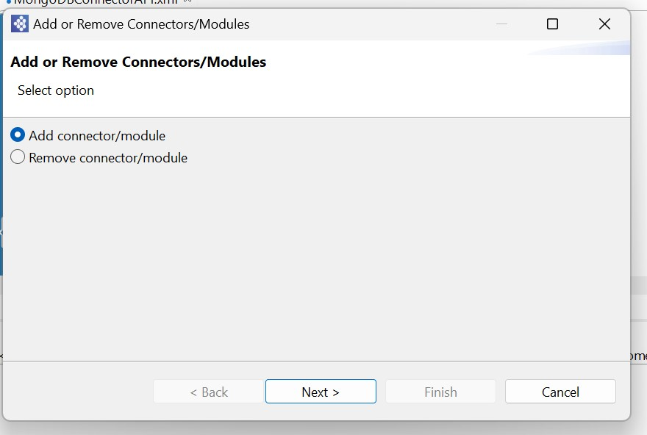

1. Click on Workspace to download connector

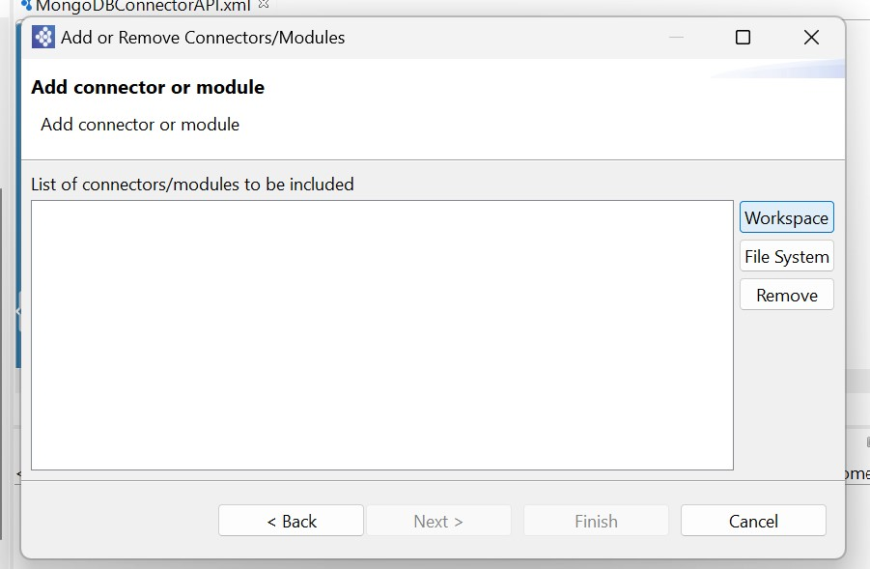

1. Search type the connector name in search box and click enter button and download connector using download button

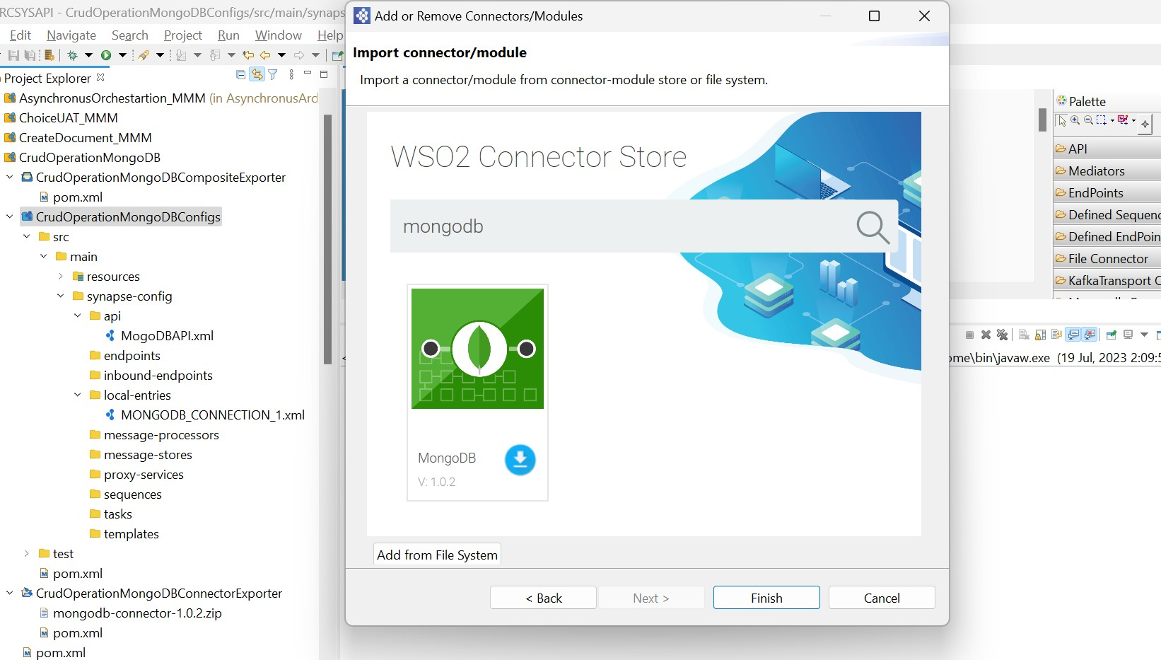

1. Click on ok and finish after downloading connector

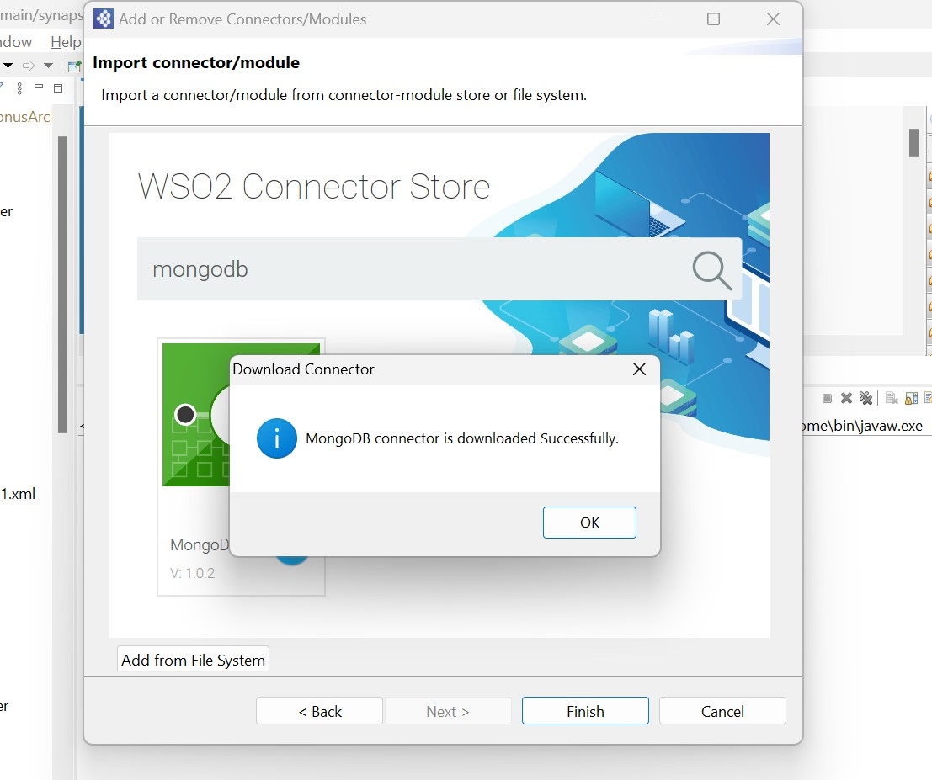

1. Right click on Connector Exporter and click on add/remove connector/module

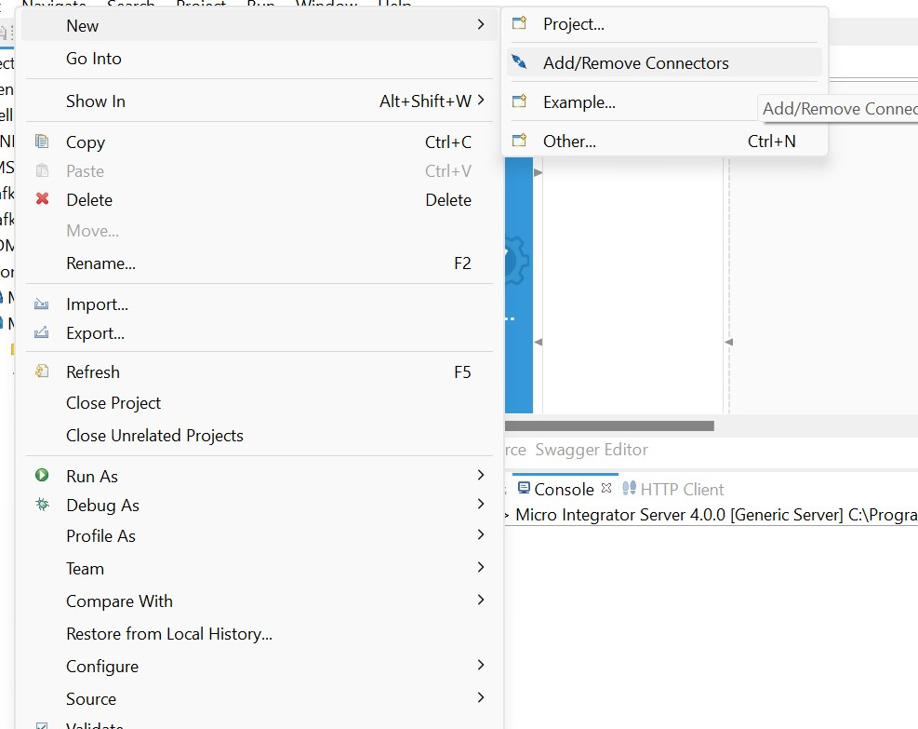

1. Click on Add connector/Module

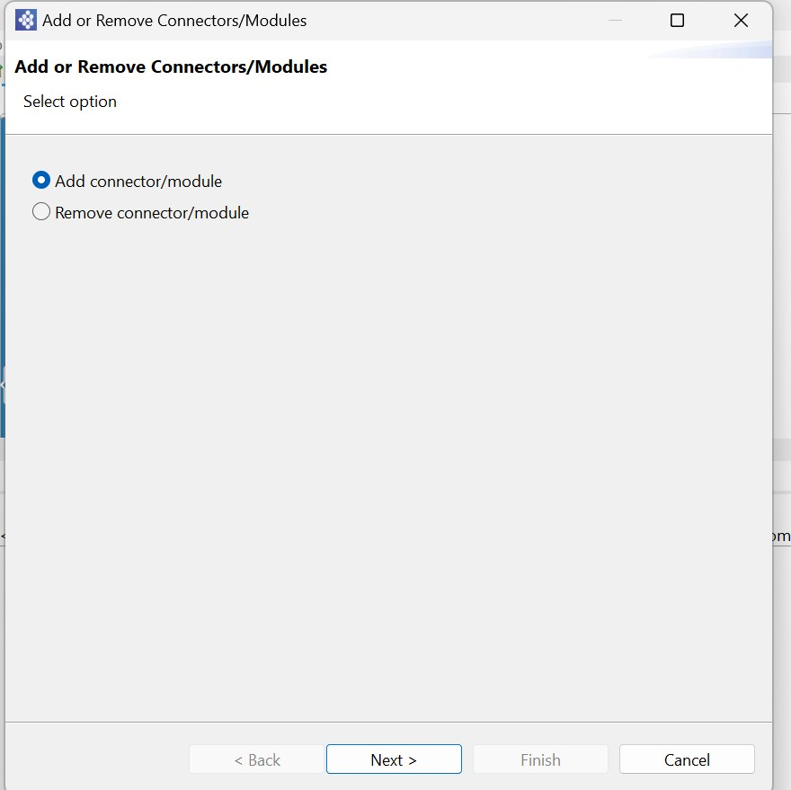

1. Click workspace to add connector exporter project



1. Select connector (MongoDB Connector)

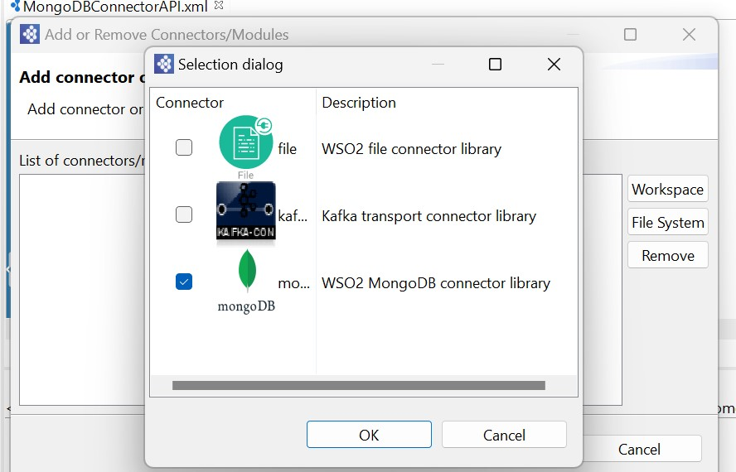

1. From the MongoDB **Connector** palette, click and drag a **inserOne** Connector to the In sequence

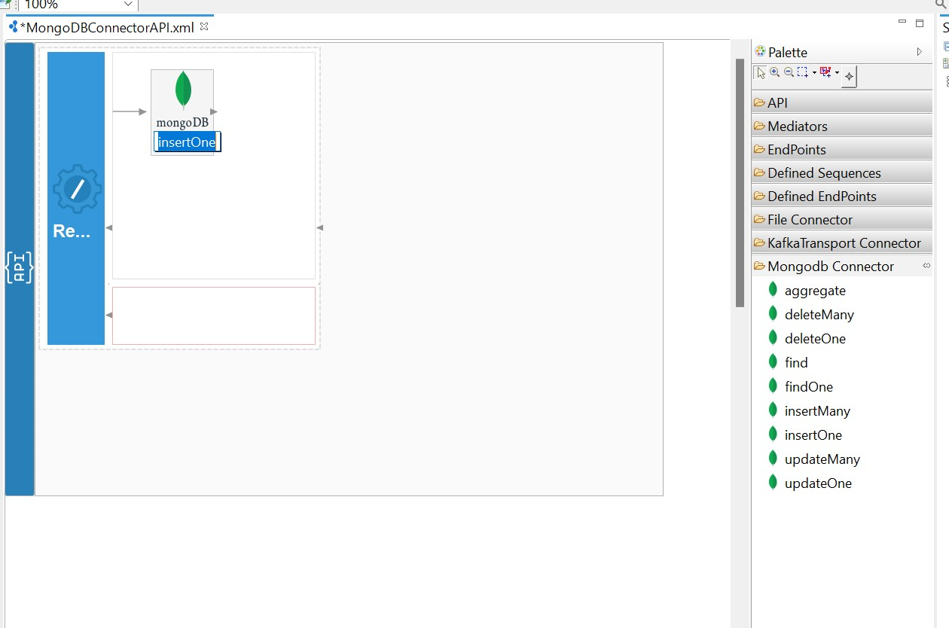

1. In property tab click add connection (+)

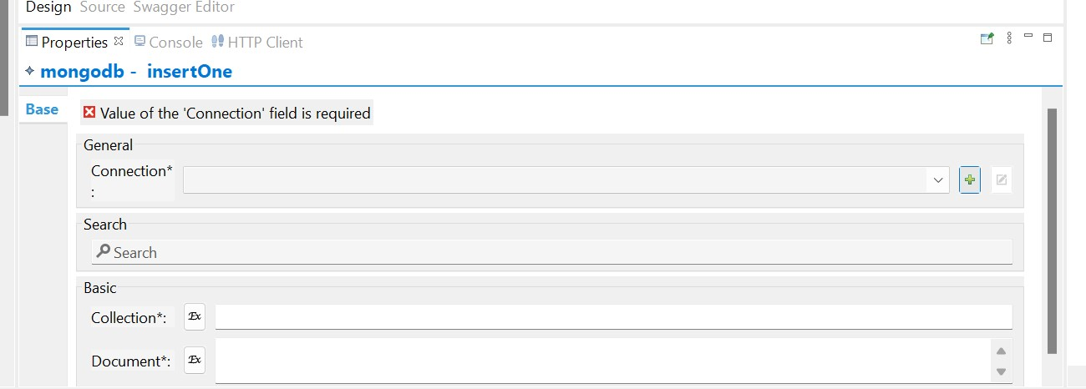

1. Enter Host name, port and data base name and click on finish

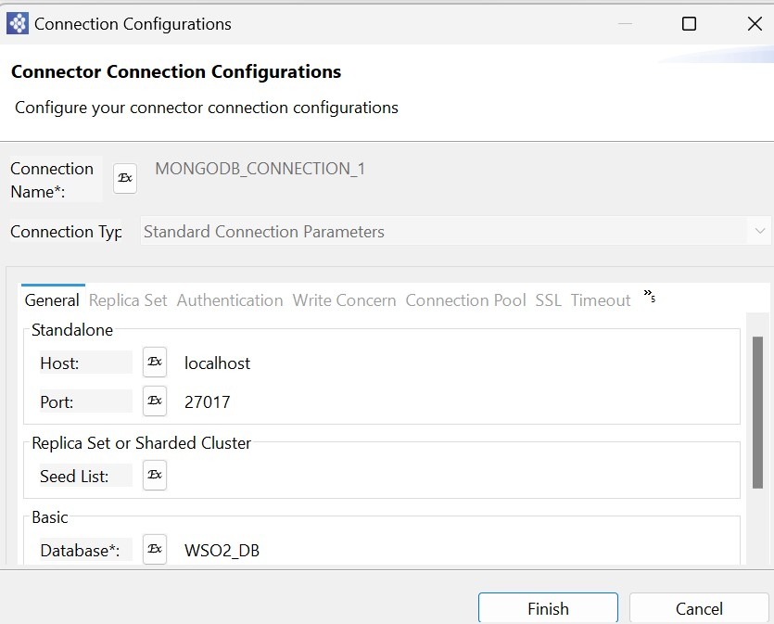

1. In insertOne connector property tab enter collection name and expression for document

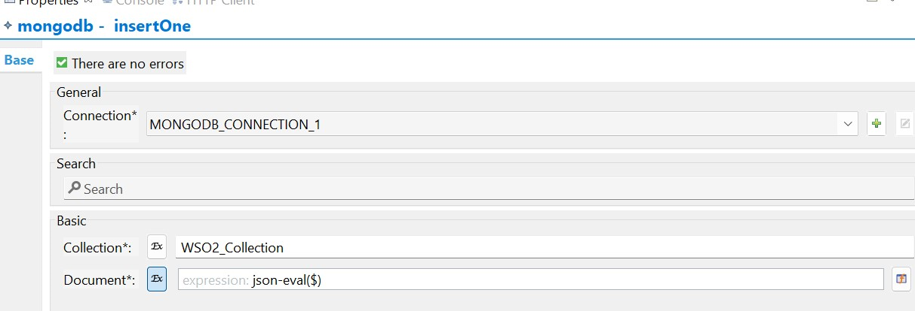

1. From the **Mediator** palette, click and drag a **respond** Mediator to the In sequence

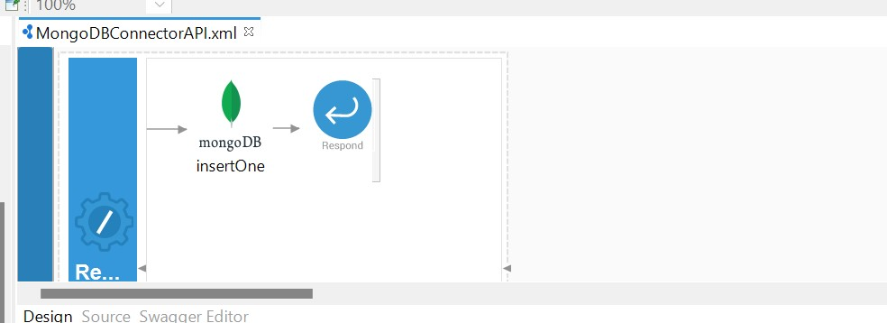

1. Right Click on the Composite Exporter and select Export project artifact and Run

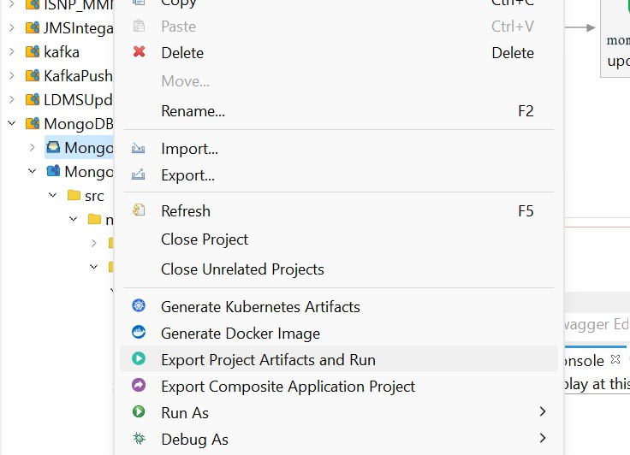

1. In post enter URL, select POST method, enter input payload and Click on Send Button get response.

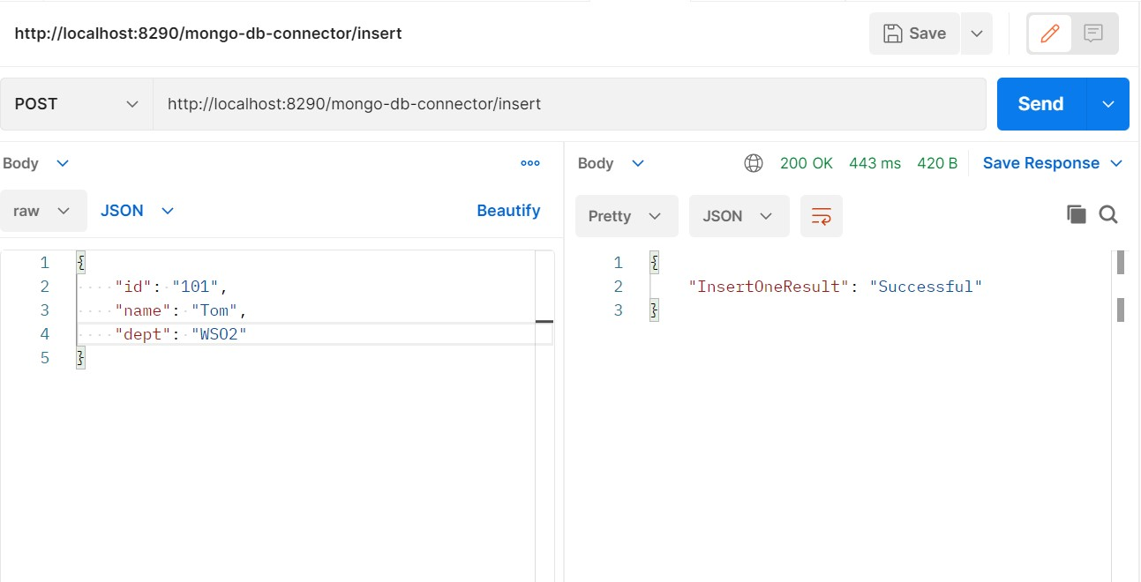

1. Open mongo DB database check data inserted or not

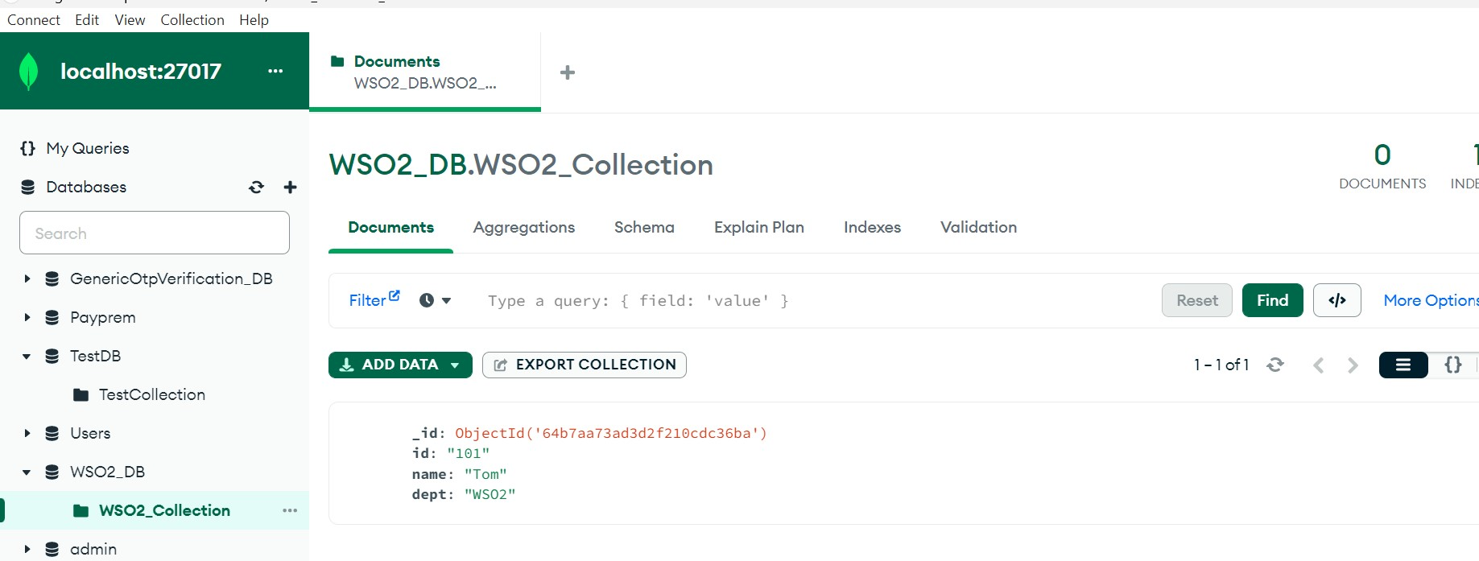

1. In the REST API configuration, select API Resource in the API palette and drag it onto the canvas just below the previous API resource that was created.
2. Click the API Resource you just added to access the Properties tab and fill in the following details:
3. From the MongoDB **Connector** palette, click and drag a **findOne** Connector to the In sequence

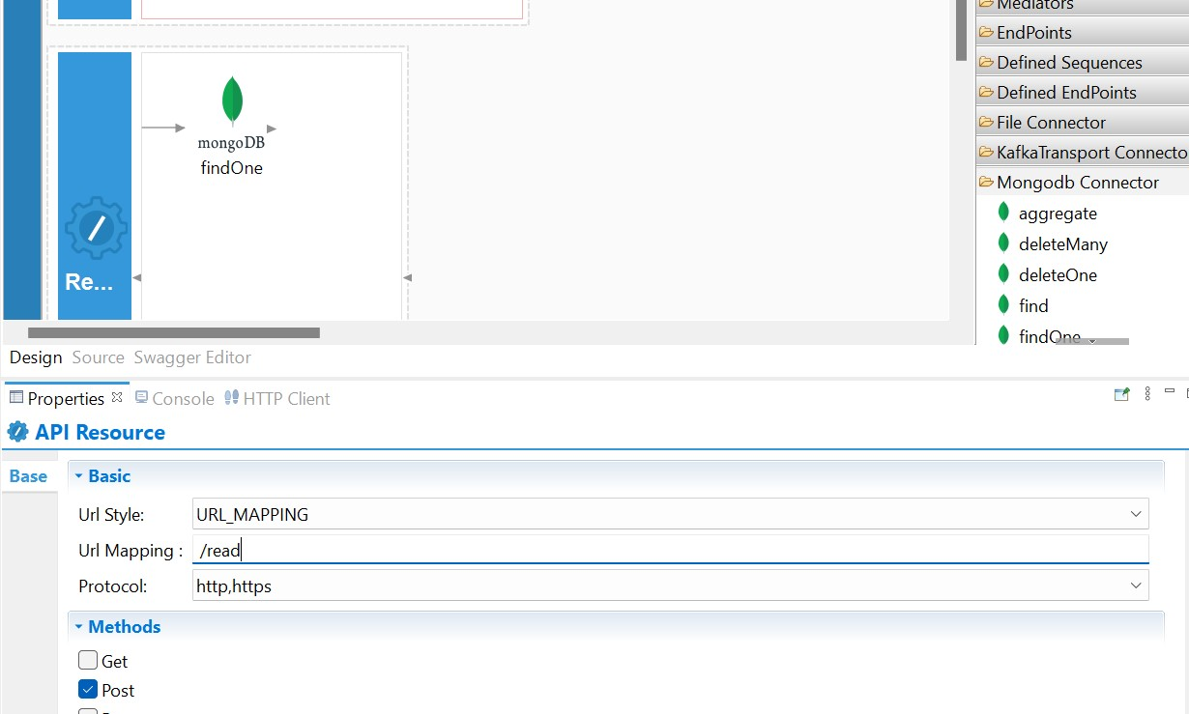

1. In findOne connector property tab select connection, enter collection name and query expression.

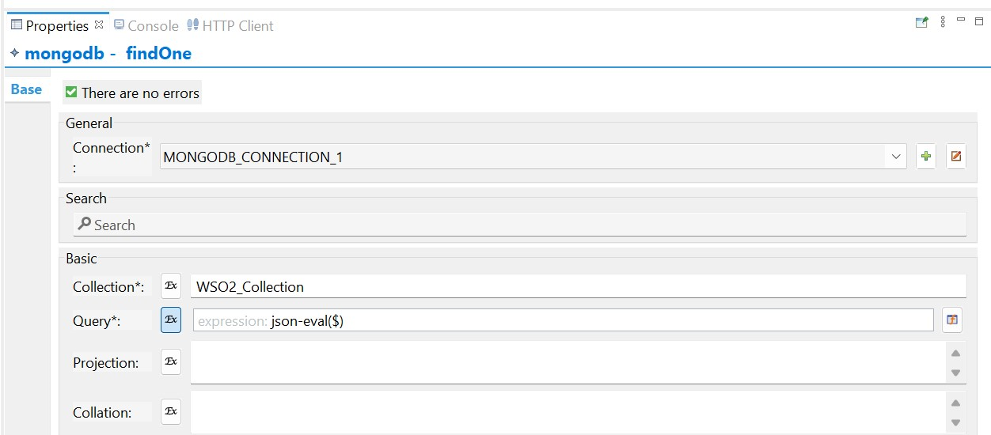

1. From the Mediator palette, click and drag a respond Mediator to the In sequence
2. Right Click on the Composite Exporter and select Export project artifact and Run



1. In post enter URL, select POST method, enter input payload and Click on Send Button get response.

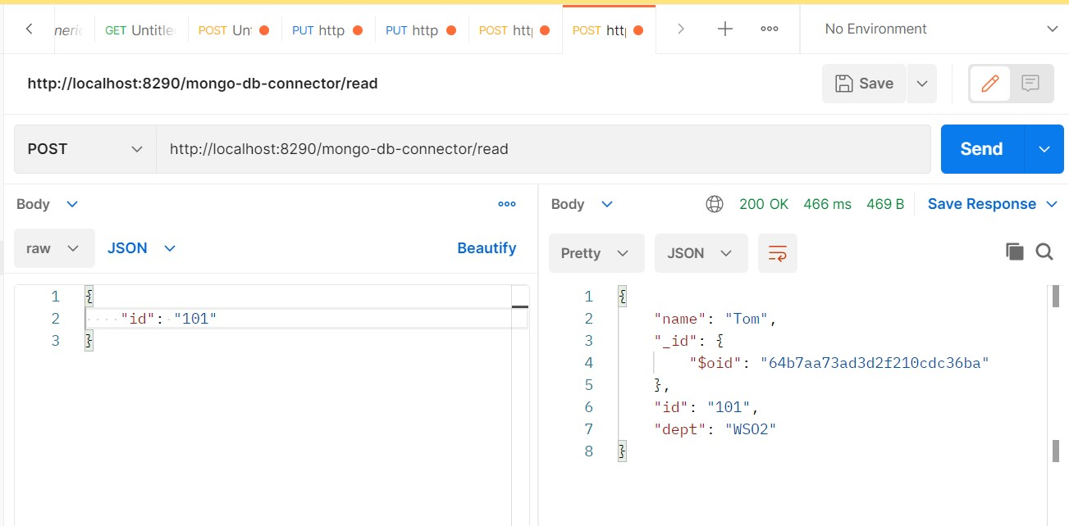

1. In the REST API configuration, select API Resource in the API palette and drag it onto the canvas just below the previous API resource that was created.
2. Click the API Resource you just added to access the Properties tab and fill in the following details:
3. From the **MongoDB Connector** palette, click and drag a **updateOne** Connector to the In sequence
4. In updateOne connector property tab select connection, enter collection name, query and update expression.
5. From the Mediator palette, click and drag a respond Mediator to the In sequence

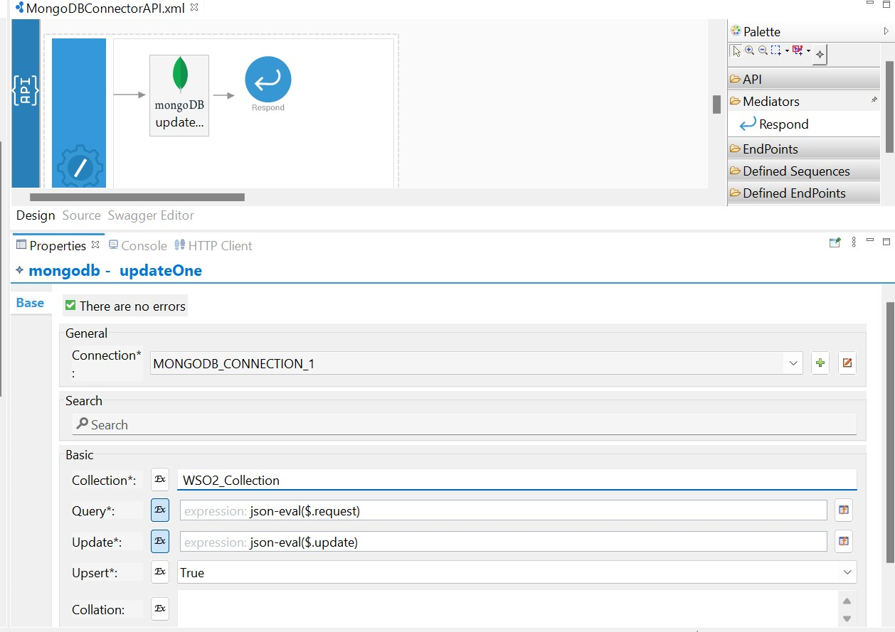

1. Right Click on the Composite Exporter and select Export project artifact and Run



1. In post enter URL, select PUT method, enter input payload and Click on Send Button get response.

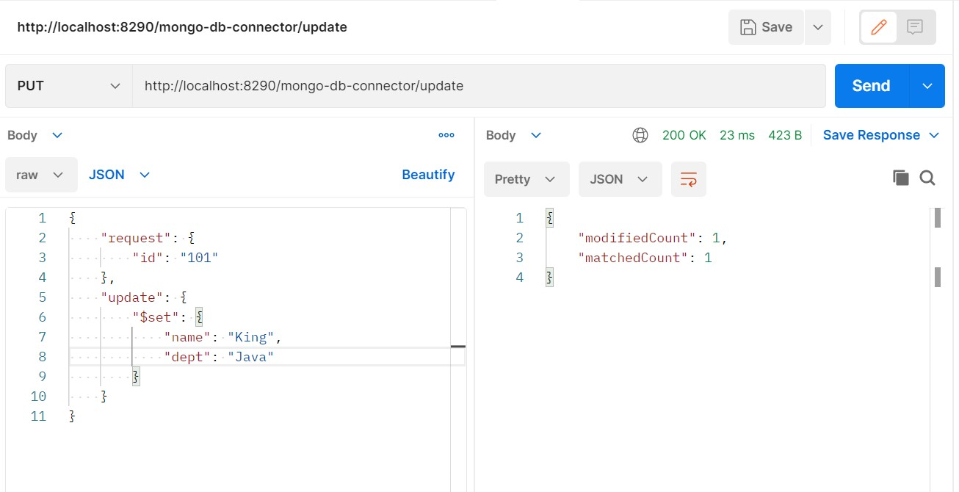

1. Open mongo DB database check data updated or not

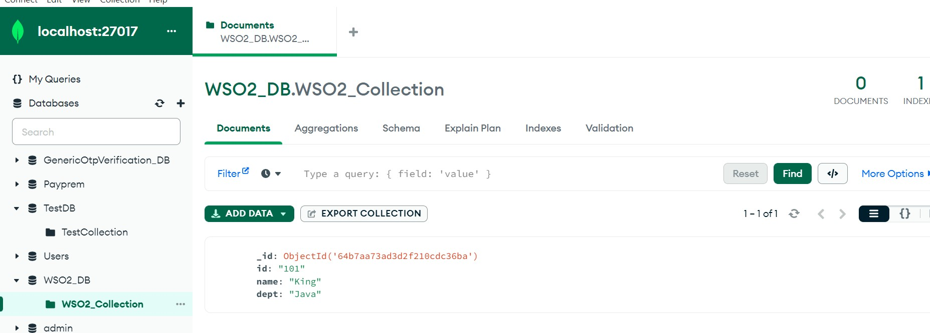

1. In the REST API configuration, select API Resource in the API palette and drag it onto the canvas just below the previous API resource that was created.
2. Click the API Resource you just added to access the Properties tab and fill in the following details:
3. From the **MongoDB Connector** palette, click and drag a **deleteOne** Connector to the In sequence
4. In deleteOne connector property tab select connection, enter collection name and query expression.
5. From the Mediator palette, click and drag a respond Mediator to the In sequence

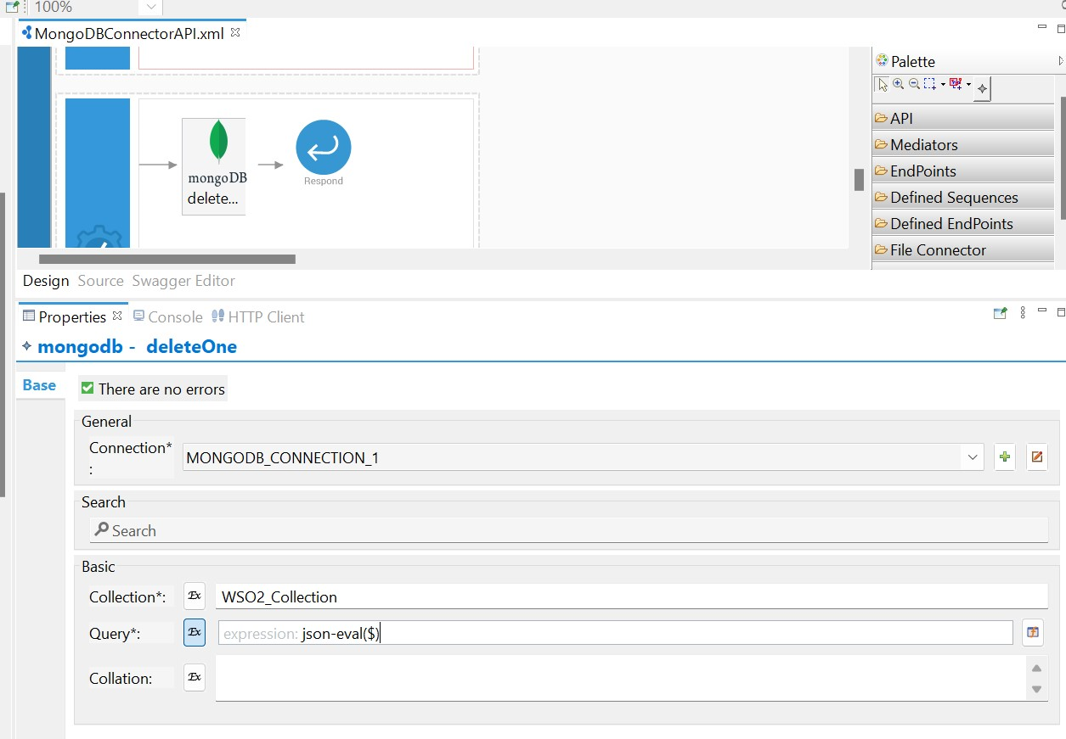

1. In post enter URL, select PUT method, enter input payload and Click on Send Button get response.

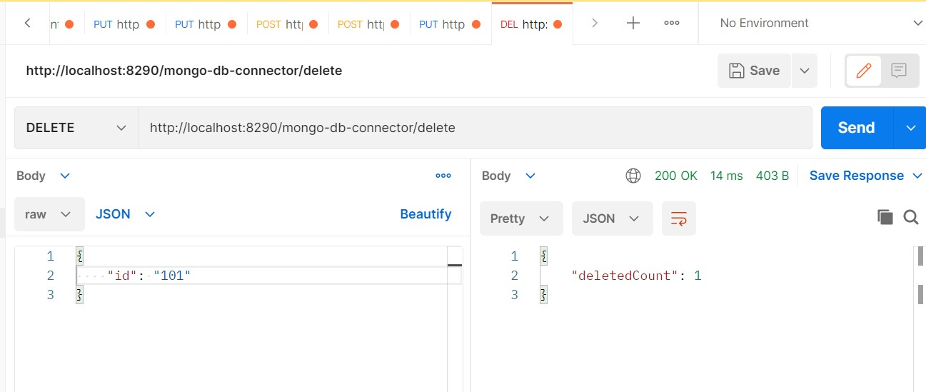

1. Open mongo DB database check data deleted or not

